Call for abstracts for PhD students
BioMarine Business Convention, 2-3-4 october 2018, Cascais Portugal
The oceans cover 70% of the Earth, allowing an exceptional richness still unknown to the public. The marine industry is a growth sector, creating jobs and investments for Governments. It regroups all activities linked to the marine environment such as energy, aquaculture, seafood, cosmetic or policy etc.
This year for the first time, BioMarine opens to PhD students. 12 selected PhDs from all over the world will have the opportunity to present their project to a large audience composed of industrials, investors and scientists. The pitching will take place inside MyBlueCity, an immersive thematic expo, where industry will present their most innovative products and services through demos.

PhD selected speakers will get: - Full access of MyBlueCity event
- 3min of pitching in front of a professional audience
- Poster diffusion just outside MyBlueCity/ lounge area
- Video streaming in the media center
If you have an innovative project and wish to participate, please complete the following form and send us a short video of your project in attached to these emails addresses before the 1st May: contact@biomarine.org and rachel.durand.1@ulaval.ca . For the inscription, subscribe to the BioMarine premium membership (administrative fee of 50€).
The winner or the 2018 pitching will:
- get a cash award form BioMarine Organization
- gain a free full pass for next year’s BioMarine Business Convention
- gain a one-year premium membership in the BioMarine Community
- benefit from one-year mentoring from BioMarine board and partners
- have your presentation run in the media center of BioMarine Community platform

Call for abstracts
Choose the section link to your project (max 2): Blue Harbour Blue city Hall Blue Restaurant Blue Tourism Blue International District Blue Spa Blue Offshore Blue Factory Blue Business
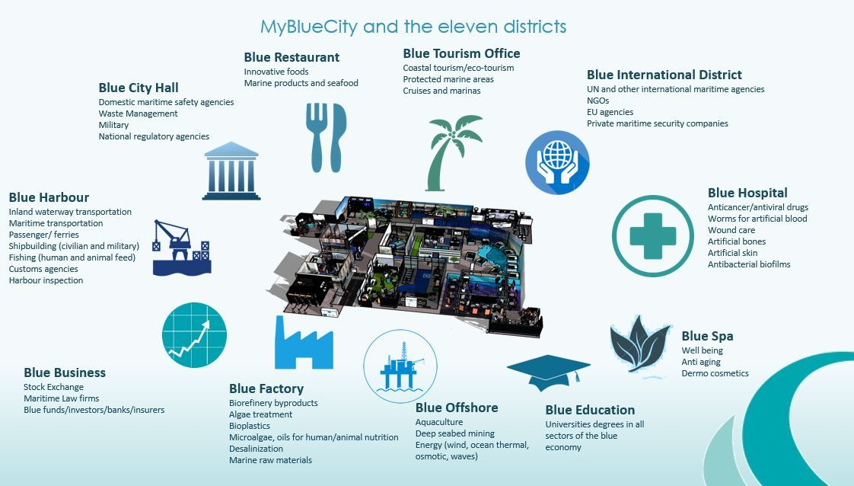

Title (200 characters):

Author 1 | Name, first name | Affiliation
Author 2 | Name, first name | Affiliation
Author 3 | Name, first name | Affiliation
Author 4 | Name, first name | Affiliation
Author 5 | Name, first name | Affiliation

Abstract (max 200 words):
Keywords (maximum 5):

Speaker: Name, first name, University
Speaker’s email:
Speaker’s director(s):
Speaker’s background (For presentation purpose before your communication) (max 50 words):
Diploma, reserch lab...

Does your research project involve industrials?
Yes |  | No
If you answered yes to the last question, name them industrial:

